Subject: Programming with Java
ASSIGNMENT No : 9
Name: Aarushi Raizada
PRN: 25070122002
CLASS: A1
TITLE : Write a Java program to demonstrate the use of the final keyword with variables, methods, and classes
Problem Statement
Write a Java program to demonstrate the use of the final keyword with variables, methods, and classes.
Learning Objectives : To implement the final keyword with variables, methods, and classes.
Theory:
The final keyword restricts modification in Java programs. A final variable cannot be reassigned after initialization. A final method cannot be overridden by subclasses, while a final class cannot be inherited. This improves security, prevents accidental modifications, and increases program reliability. Final is commonly used for constants and immutable classes.
Exercise 1
1.Create a Bank Account program where account number is final and cannot be changed.

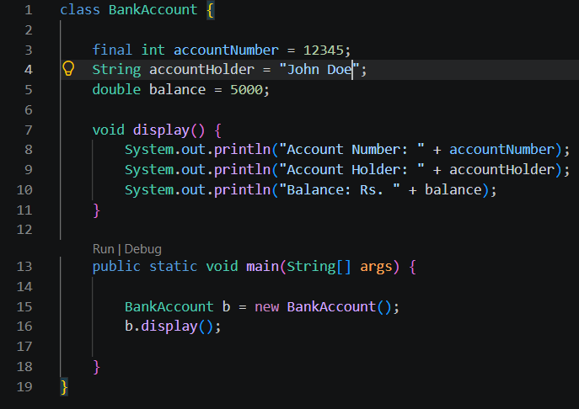
OUTPUT:
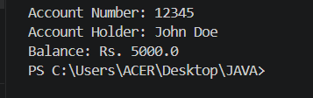
2. Create a Library Book Management program where the book ISBN is declared as final and cannot be changed once assigned. Display the book's ISBN, title, author, and price.
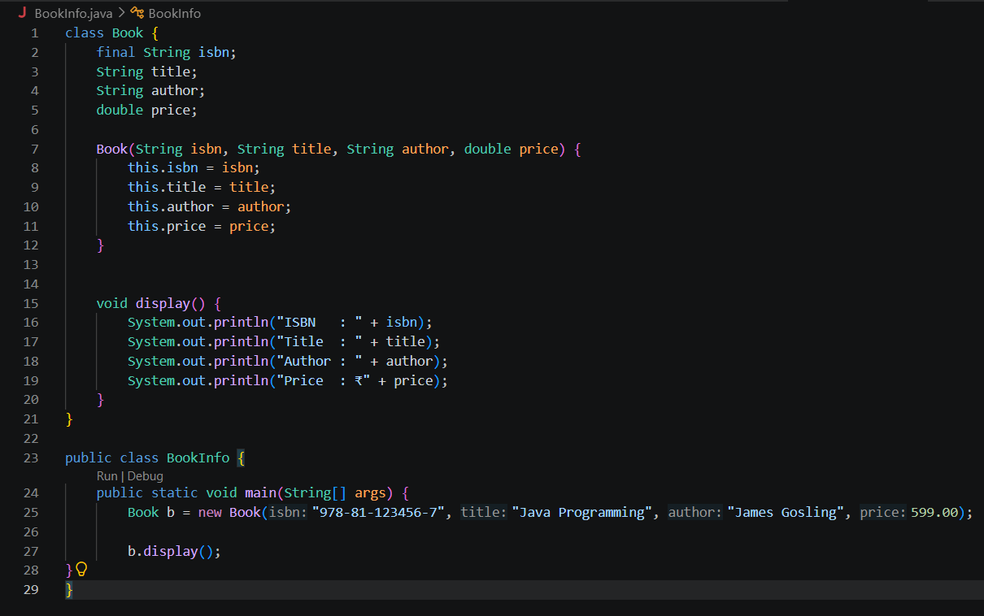
OUTPUT:
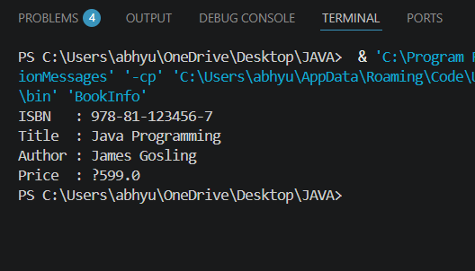
Conclusion:
The programs successfully demonstrate the use of the final keyword in Java. By declaring the account number and book ISBN as final, they cannot be modified after initialization, ensuring data integrity. The final keyword helps prevent accidental changes, improves security, and makes Java programs more reliable and maintainable.

